Configuring Mysql 5.5 with Rails 3 and Ruby 1.9.2 on Windows XP/7

In this tutorial it’s assumed that you have Ruby on Rails installed on your PC.

Pre-requisits:
* Mysql2 gem
* Ruby DevKit
[The mysql2 gem requires some native extensions, so you'll need the DevKit or the gem can't be built properly.]
a) If you installed RoR using http://www.railsinstaller.org/ then you don’t need DevKit, it is included in the package.
b) If you installed every component manually the you can doanload DevKit from here http://rubyinstaller.org/downloads and then follow the installation instructions from here https://github.com/oneclick/rubyinstaller/wiki/Development-Kit

1.
Download and install MySQL - http://dev.mysql.com/downloads/
I used MySQL Windows Installer to install MySQL
Make sure to mark the checkbox that says “Include BIN Directory in Windows PATH” during installation and also add exceptions for MySQL to your firewall/antivirus (I had some issues with Nod32 blocking mysql connections).

During the installation the following options were checked

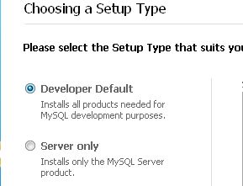

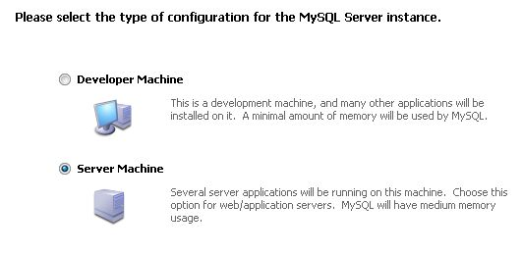

The rest of the install seems pretty much next, next, next.
2.
Reboot and check that your MySQL is now working.

You can test it by simply connecting it with Workbench GUI to your database, or you can you command line to test the connection as described below.

mysql -u root if you left the password for root empty during installation (which is NOT good idea by the way), or
mysql -u root --password=<your password here>
You can simply do mysql -u root –password
And then you will be prompted for password (it’s a bit better because you don’t need to type the password in clear text)

You should get something that looks like this:
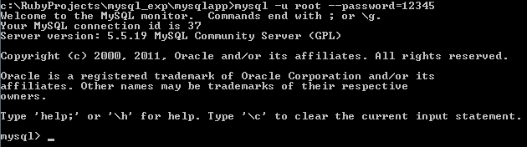

Which means that you’ve successfully connected to your MySQL instance. Type exit to get out of mysql cmd.

3
Install mysql2 gem. Use the following command:
D:\work\osci>gem install mysql2 -- '--with-mysql-lib="c:\Program Files\MySQL\MySQL Server 5.5\lib" --with-mysql-include="
c:\Program Files\MySQL\MySQL Server 5.5\include"'

* It is all one command
* Note the careful use of quotes.

The output will look like this:
==================================================================

You've installed the binary version of mysql2.
It was built using MySQL Connector/C version 6.0.2.
It's recommended to use the exact same version to avoid potential issues.

At the time of building this gem, the necessary DLL files where available
in the following download:

http://dev.mysql.com/get/Downloads/Connector-C/mysql-connector-c-noinstall-6.0.2-win32.zip/from/pick

And put lib\libmysql.dll file in your Ruby bin directory, for example C:\Ruby\bin

==================================================================

Successfully installed mysql2-0.3.11-x86-mingw32
1 gem installed
Installing ri documentation for mysql2-0.3.11-x86-mingw32...
Installing RDoc documentation for mysql2-0.3.11-x86-mingw32...

********

4.

The output of the previous command idnicated:
“At the time of building this gem, the necessary DLL files where available in the following download:
http://dev.mysql.com/get/Downloads/Connector-C/mysql-connector-c-noinstall-6.0.2-win32.zip/from/pick
And put lib\libmysql.dll file in your Ruby bin directory, for example C:\Ruby\bin”

So now we have to do as we’re told.

5.
Create a new rails project:
rails new myapp --database=mysql

[By using the “--database=mysql” option you specify to rails that mysql is to be used as a DB adapter instead of the default one (SQLite3). This is not absolutely necessary, you can just edit the database.yml file and add the “mysql2” gem to your Gemfile in your project.]

*****
Your output should look like this

D:\work>rails new ossci --database=mysql
exist
create README
create Rakefile
create config.ru
create .gitignore
create Gemfile
create app
create app/assets/images/rails.png
create app/assets/javascripts/application.js
create app/assets/stylesheets/application.css
create app/controllers/application_controller.rb
create app/helpers/application_helper.rb
create app/mailers
create app/models
create app/views/layouts/application.html.erb
create app/mailers/.gitkeep
create app/models/.gitkeep
create config
create config/routes.rb
create config/application.rb
create config/environment.rb
create config/environments
create config/environments/development.rb
create config/environments/production.rb
create config/environments/test.rb
create config/initializers
create config/initializers/backtrace_silencers.rb
create config/initializers/inflections.rb
create config/initializers/mime_types.rb
create config/initializers/secret_token.rb
create config/initializers/session_store.rb
create config/initializers/wrap_parameters.rb
create config/locales
create config/locales/en.yml
create config/boot.rb
create config/database.yml
create db
create db/seeds.rb
create doc
create doc/README_FOR_APP
create lib
create lib/tasks
create lib/tasks/.gitkeep
create lib/assets
create lib/assets/.gitkeep
create log
create log/.gitkeep
create public
create public/404.html
create public/422.html
create public/500.html
create public/favicon.ico
create public/index.html
create public/robots.txt
create script
create script/rails
create test/fixtures
create test/fixtures/.gitkeep
create test/functional
create test/functional/.gitkeep
create test/integration
create test/integration/.gitkeep
create test/unit
create test/unit/.gitkeep
create test/performance/browsing_test.rb
create test/test_helper.rb
create tmp/cache
create tmp/cache/assets
create vendor/assets/stylesheets
create vendor/assets/stylesheets/.gitkeep
create vendor/plugins
create vendor/plugins/.gitkeep
run bundle install
Fetching source index for http://rubygems.org/
Using rake (0.9.2.2)
Using multi_json (1.0.4)
Using activesupport (3.1.1)
Using builder (3.0.0)
Using i18n (0.6.0)
Using activemodel (3.1.1)
Using erubis (2.7.0)
Using rack (1.3.6)
Using rack-cache (1.1)
Using rack-mount (0.8.3)
Using rack-test (0.6.1)
Using hike (1.2.1)
Using tilt (1.3.3)
Using sprockets (2.0.3)
Using actionpack (3.1.1)
Using mime-types (1.17.2)
Using polyglot (0.3.3)
Using treetop (1.4.10)
Using mail (2.3.0)
Using actionmailer (3.1.1)
Using arel (2.2.1)
Using tzinfo (0.3.31)
Using activerecord (3.1.1)
Using activeresource (3.1.1)
Installing ansi (1.4.1)
Using bundler (1.0.21)
Using coffee-script-source (1.2.0)
Using execjs (1.2.13)
Using coffee-script (2.2.0)
Using rack-ssl (1.3.2)
Using json (1.6.4)
Using rdoc (3.12)
Using thor (0.14.6)
Using railties (3.1.1)
Using coffee-rails (3.1.1)
Using jquery-rails (1.0.19)
Using mysql2 (0.3.11)
Using rails (3.1.1)
Using sass (3.1.12)
Using sass-rails (3.1.5)
Installing turn (0.8.3)
Using uglifier (1.2.1)
Your bundle is complete! Use `bundle show [gemname]` to see where a bundled gem is installed.

D:\work>

6.

Here is how the database.yml should look now

# MySQL. Versions 4.1 and 5.0 are recommended.
#
# Install the MYSQL driver
# gem install mysql2
#
# Ensure the MySQL gem is defined in your Gemfile
# gem 'mysql2'
#
# And be sure to use new-style password hashing:
# http://dev.mysql.com/doc/refman/5.0/en/old-client.html
development:
adapter: mysql2
encoding: utf8
reconnect: false
database: oshanter_development
pool: 5
username: root
password: absdef
host: localhost

# Warning: The database defined as "test" will be erased and
# re-generated from your development database when you run "rake".
# Do not set this db to the same as development or production.
test:
adapter: mysql2
encoding: utf8
reconnect: false
database: osci_test
pool: 5
username: root
password: abcdef
host: localhost

production:
adapter: mysql2
encoding: utf8
reconnect: false
database: oshanter_production
pool: 5
username: root
password: abcdef
host: localhost

7. Change into the newly created application directory and issue
rake db:create:all

This will create all the databases specified in the database.yml configuration file.

The command does not produce any output:

D:\work\osci>rake db:create:all

D:\work\osci>

9. Run
rails server
and check that your application is up and running.
You should see the out put similar to this:

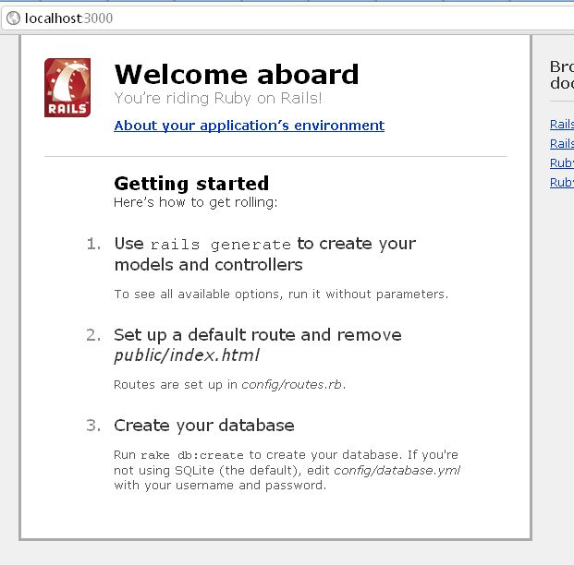

That’s it, you should be up and runnng now

***

Some error messages I had and issues I eventually solved

1. If you don’t have the DevKit installed you get this one:
C:\>gem install mysql2
ERROR: Error installing mysql2:
The ‘mysql2′ native gem requires installed build tools.
Please update your PATH to include build tools or download the DevKit
from ‘http://rubyinstaller.org/downloads’ and follow the instructions
at ‘http://github.com/oneclick/rubyinstaller/wiki/Development-Kit’

2. “Uninitialized constant Mysql2” error when executing the rake db:create:all command:
rake aborted!
uninitialized constant Mysql2::Error

Make sure to add the mysql2 gem to your Gemfile, configure the database.yml file to use mysql2 and run the bundle install command.
3. “Can't convert Fixnum into String” error message when executing the rake db:create:all command:
rake aborted!
can't convert Fixnum into String
This happens when you have a digital password without the quotation marks in the database.yml file, i.e. password: 123.
Add some quotes and you’ll be fine: password: "123"

